**Assignment 3**

In this assignment, you are to design and code a program as specified below:

1. As shown below, when user clicks a button labeled *circle*, *rectangle*, or *triangle*, he/she would then be able to click the mouse on the canvas area to draw an indicated shape (circle, rectangle, or triangle) at the mouse location. Note that all previously drawn shapes are always visible (even when the frame is resized or restored from an icon).

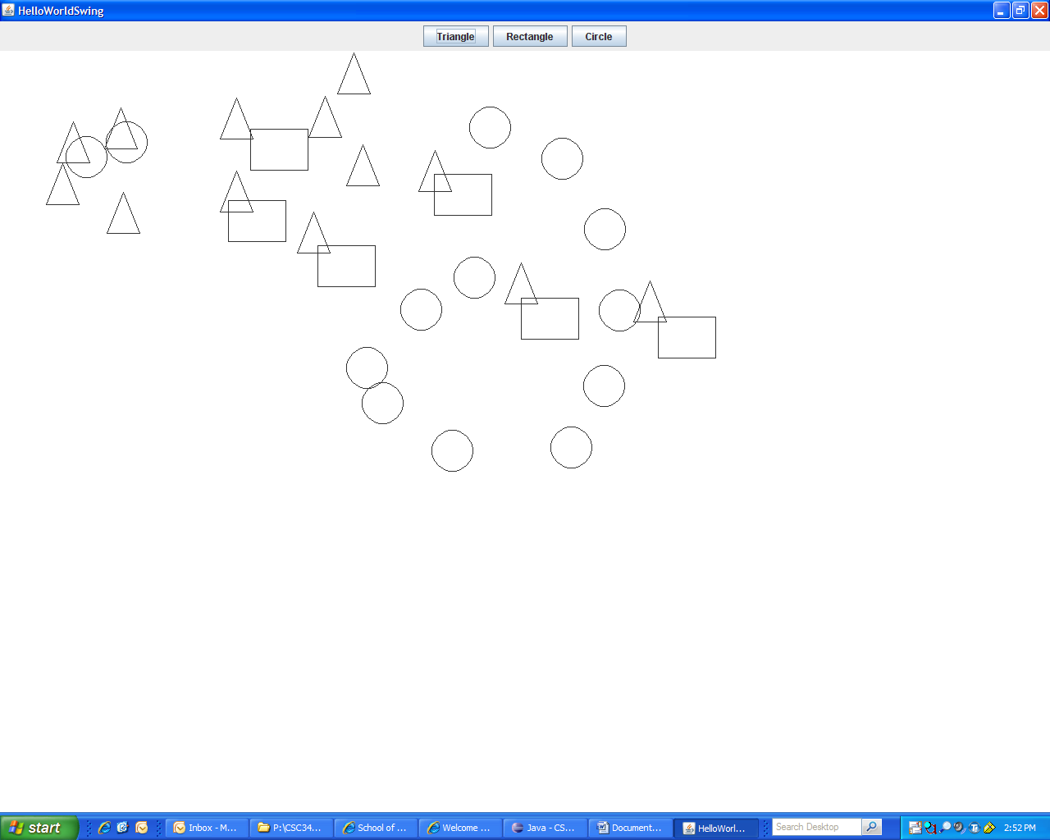

1. At the bottom of the interface, add a text box to allow entering a shape size. The entered number would be the side length for triangles and rectangles (triangles would be equal-lateral, and the other side of a rectangle would a fixed proportion of the given side length), or the diameter of circles. Add a button to allow the size to apply to the next shape to draw. Also, add another button to clear the canvas.
2. A design consideration is that you might need to extend the program by adding other shapes later (such as half-circle, line segment, etc.) without significant modification to the existing structure of the program. Polymorphism would help to achieve that.

**Notes:**

1. If you call “*repaint()*” method, which would in turn calls *paintComponent()*), then it would erase the current drawing on the canvas, and paintComponent() method would put a new drawing on if any.
2. Java GUI is an interesting topic. There are usually multiple ways to do the same thing. Web search perhaps is the most effective way to know “how” (just searching a phrase about what you try to do).